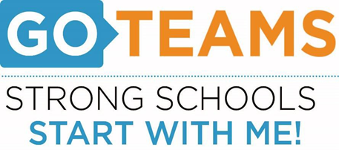

**Meeting Agenda**

**Sylvan Hills Middle School (Virtual Zoom)**

**Thursday, October 1, 2020**

**5:00 PM**

**Join Zoom Meeting**  
[**https://atlantapublicschools-us.zoom.us/j/83792536087?pwd=a240WEVtamtZRDFoNytDL1pnWk83QT09**](https://atlantapublicschools-us.zoom.us/j/83792536087?pwd=a240WEVtamtZRDFoNytDL1pnWk83QT09)

**Meeting ID: 837 9253 6087   
Passcode: 677102**

1. **Call to Order**
2. **Roll Call; Establish Quorum**
3. **Action Items** 
   1. Approval of Agenda
   2. Fill Open Community Member Seat
   3. Approval of Previous Minutes
   4. Review and Approve Public Comment Format
   5. Review, Confirm/Update, and Adopt GO Team Norms
   6. Establish and Approve next Go Team Meeting date
4. **Information Items** 
   1. Return + Learn Plan
   2. Principal’s Report
   3. Update on GO Team Members – 20-21
5. Announcements
   1. Announcement